### **Objective**

This distance learning program is intended to serve as an introduction into President Ulysses S. Grant’s Indian policies and the consequences of those policies. Students will be introduced to several primary source documents ahead of the ranger’s presentation to provide brief background information about 19th century U.S. Indian policy. During the virtual presentation, the ranger will lead a facilitated dialogue with students to examine the concept of “Manifest Destiny,” the growth of Indian reservations, and their connections to Grant’s presidency. By the end of the lesson, students will better understand the nature of President Grant’s Indian policies and consider the ways their own lifestyle has been shaped by outside forces such as government, schools, and family decisions.

### **Pre-Visit Resources**

* [“Invasion of America”](http://usg.maps.arcgis.com/apps/webappviewer/index.html?id=eb6ca76e008543a89349ff2517db47e6) Interactive Map
* Article: Smithsonian American Art Museum, [“Manifest Destiny and Indian Removal”](https://americanexperience.si.edu/wp-content/uploads/2015/02/Manifest-Destiny-and-Indian-Removal.pdf)
* Painting: “Westward the Course of Empire Takes Its Way,” by Emanuel Leutze (1860)
* Painting: “American Progress,” by John Gast (1872)
* Political Cartoon: “Robinson Cruse Makes a Man of his Friday,” by Thomas Nast (1871)
* Speech: President Ulysses S. Grant’s First Annual Address to Congress, December 6, 1869
* Letter: President Ulysses S. Grant to General John Schofield, March 6, 1872
* Speech: Red Cloud Speech at Cooper Union, July 16, 1870
* Letter: Ely S. Parker to Harriet Converse, 1885

1. All students will do an activity using the “Invasion of America” map and [read the Smithsonian article](https://americanexperience.si.edu/wp-content/uploads/2015/02/Manifest-Destiny-and-Indian-Removal.pdf) for background information on the concept of “Manifest Destiny.” The remainder of the pre-visit resources will be divided among the students.
2. Each student will closely examine one political cartoon (click on hyperlinks within titles for larger images) and at least one letter/speech. The teacher may elect to have the students work in groups or individually.
3. During the virtual meeting, the ranger will facilitate a conversation with students about Grant’s Indian Policies using the materials that the students worked on ahead of time.

## **Vocabulary Sheet**

**Civilization:** A set of ideals from the Enlightenment Era (17th and 18th centuries) held by many Americans of European ancestry. While individual beliefs varied, “civilization” often meant a belief in a republican form of government, literacy, science, Christianity, private property, and a desire to transition Indians from hunters to farmers.

**Great Father:** A term sometimes used by Indians to refer to the President of the United States.

**Manifest Destiny:** The belief that it was God’s will that all land from the Pacific Ocean (west) to the Atlantic Ocean (east) was destined to be owned and controlled by the U.S. government, without regard for the well-being of the various Indian tribes who had already settled on these lands prior to European settlement.

**Territory:** In U.S. law, an area of land that has applied for statehood and is working to write a state constitution and become a state.

**Treaty:** A formal agreement ratified between two countries. Although U.S. politicians in the 19th century often debated whether Indian tribes were their own formal countries or a part of the United States, treaties were used to establish formal agreements on land ownership and usage between tribes and the U.S. government. Many treaties between tribes and the government remain in effect today, although many have been violated by the government.

**Tribe:** a group of people with a common culture, language, and a family or cultural connection. Tribes usually have one or more recognized leaders.

## **Activity A:** [**“Invasion of America”**](http://usg.maps.arcgis.com/apps/webappviewer/index.html?id=eb6ca76e008543a89349ff2517db47e6) **Interactive Map**

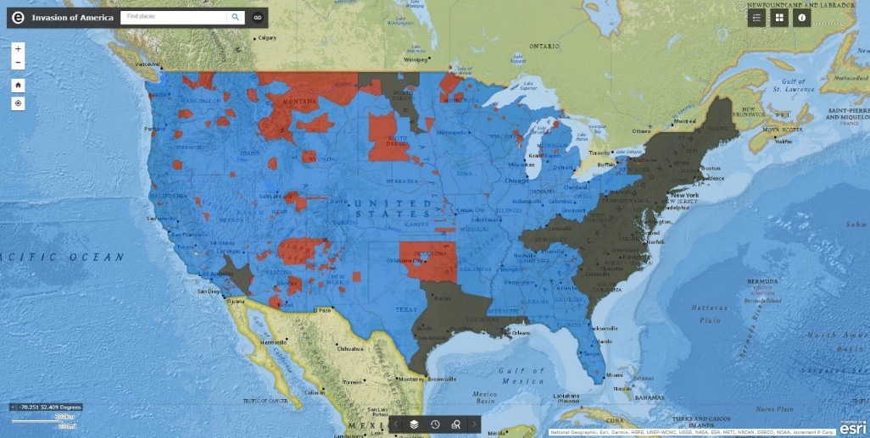

1. **Without looking the term up, what do you think is the purpose of an Indian reservation?**
2. **Watch** [**this video**](https://www.youtube.com/watch?v=pJxrTzfG2bo) **that accompanies the interactive map. When and where do you start to see the first Indian reservations established?**
3. **Ulysses S. Grant was president from 1869 to 1877. What are some of the major land changes you see during his presidency in this video?**
4. **Go back to the website and click on St. Louis. When were these lands ceded to the U.S. Government through treaty? What Indian tribe occupied these lands?**
5. **Click on the “layers” feature on the bottom of the page and click “Current Reservations.” Are there any Indian reservations in Missouri? List five tribes that live in or near Missouri.**

## **Activity A: “**[**Manifest Destiny and Indian Removal**](https://americanexperience.si.edu/wp-content/uploads/2015/02/Manifest-Destiny-and-Indian-Removal.pdf)**” article (Smithsonian American Art Museum)**

1. **How does this article define the “self-serving concept of Manifest Destiny”?**
2. **What were Thomas Jefferson’s views towards American Indians? Briefly describe his ideas, including his belief in “assimilation.”**
3. **Why did President James Monroe disagree with Thomas Jefferson about Indian assimilation?**
4. **What was the Trail of Tears?**
5. **Look at the map on page 5. Which one of the five listed tribes traveled through Missouri during the Trail of Tears?**

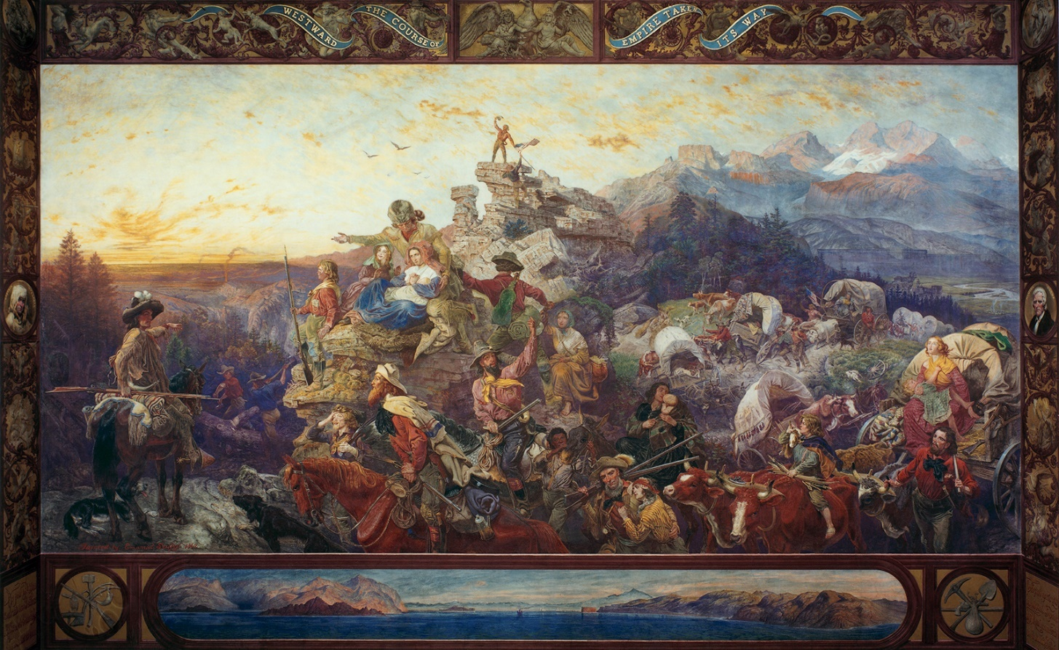**Activity B: Painting, “**[**Westward the Course of Empire Takes its Way**](https://www.aoc.gov/explore-capitol-campus/art/westward-course-empire-takes-its-way)**,” by Emanuel Leutze (1860)**

1. **What do you see in this painting? List at least five objects, activities, and people you see in this painting.**
2. **What was happening in the United States when this painting was created?**
3. **What does this cartoon say about the role of men and women in American society?**
4. **Who or what is missing from this photo, if anything?**
5. **Do you think this image supports the idea of Manifest Destiny? How so?**

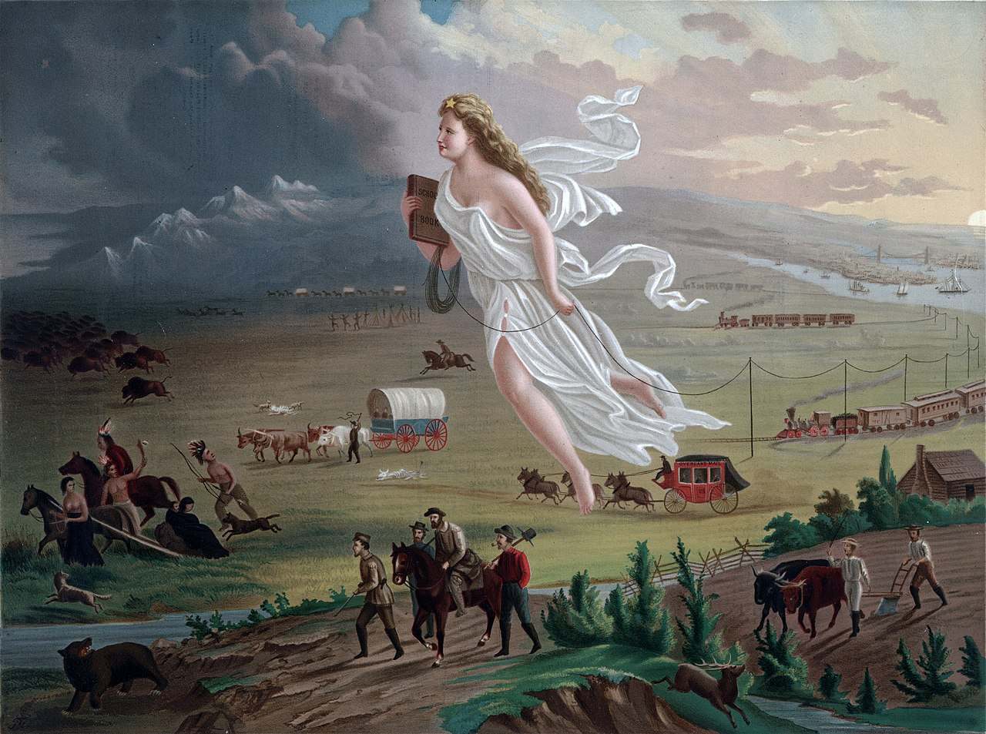**Activity B: Painting: “**[**American Progress**](https://upload.wikimedia.org/wikipedia/commons/thumb/f/fd/American_Progress_%28John_Gast_painting%29.jpg/1280px-American_Progress_%28John_Gast_painting%29.jpg)**,” by John Gast (1872)**

1. **What is the first thing you notice about this painting?**
2. **List at least five people, objects, and places depicted in the cartoon.**
3. **What do you think the objects in this painting represent?**
4. **What do you think the artist John Gast meant by the term “American Progress”?**

## **Activity B: Political Cartoon, “**[**Robinson Crusoe Making a Man of his Friday**](https://upload.wikimedia.org/wikipedia/commons/a/ab/Robinson_Crusoe_making_a_man_of_his_Friday_-_Th._Nast._LCCN2003653580.jpg)**,” Thomas Nast (1871)**

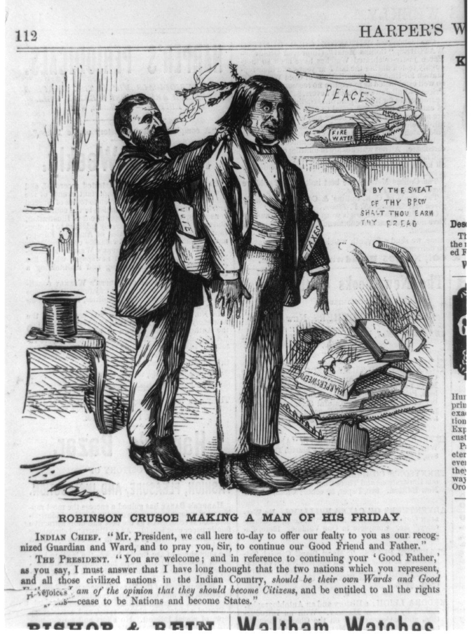

*(*Robinson Crusoe *was a popular story written by Daniel Defoe in 1719. Crusoe experiences a shipwreck and is stranded on an island near Venezuela. After living on the island for 25 years, he discovers Native peoples who also live on the island and are cannibalistic. One of the natives becomes the servant of Crusoe, who names him “Friday” for the day of the week when they first met. Crusoe teaches English and Christianity to Friday and teaches him that cannibalism is wrong. The book intended to educate readers about the enlightening values of Christianity and “civilization.”)*

1. **What do you first notice with this cartoon?**
2. **What are some of the objects in this cartoon? What do you think they symbolize?**
3. **How does this cartoon depict President Grant’s ideas about Indians?**
4. **Going back to the Smithsonian article, do you think Grant’s views were more in line with Thomas Jefferson or James Monroe?**

## **Activity C: Ulysses S. Grant Speech and Letter**

Excerpt from First Annual Message to Congress, December 6th, 1869

“From the foundation of the Government to the present the management of the original inhabitants of this Continent, the Indian, has been one of embarrassment, and expense, and has been attended with continuous robberies, murders, and wars. From my own experience upon the frontiers, and in Indian countries, I do not hold either legislation, or the conduct of the whites who come most in contact with the Indian, blameless for these hostilities. The past however can not be undone, and the question must be met as we now find it. I attempted a new policy towards these wards of the Nation with fair results, so far as tried, and I hope to be attended ultimately with great success. The Society of Friends [Quakers] are well known as having succeeding in living in peace with the Indian in the early settlement of Pa. while their White neighbors of other sects, in other sections, did not do so. They are also known for their opposition to all strife, violence and war, and are generally noted for their strict integrity and fair dealings. These considerations induced me to give the management of a few reservations of Indians to them . . .

The building of railroads and the access thereby given to all the agricultural and mineral regions of the country is rapidly bringing civilized settlements in contact with all the tribes of Indians. No matter what ought to be the relations between such settlements and the aborigines, the fact is they do not get on together, and one or the other has to give way in the end. A system which looks to the extinction of a race is too abhorrent for a Nation to indulge in without entailing upon the wrath of all Christendom, and without engendering in the Citizen a disregard for human life, and the rights of others, dangerous to society. I see no remedy for this except in placing all the Indians on large reservations[s], as rapidly as can be done, and giving them absolute protection there. As rapidly as they are fitted for it they should be induced to take their lands in severalty and should be induced to set up territorial governments for their own protection.”

To Major General John M. Schofield, March 6th, 1872

“The anxiety felt by the public generally, and by myself in particular, that Indian hostilities should be avoided in the future, and a policy to civilize and elevate the Indian prove successful, has induced the sending out of a commissioner to study the present condition of Indian affairs in Arizona and, if possible, to suggest a means for accomplishing the end aimed at . . .

Indians who will not put themselves under the restraints required will have to be forced, even to the extent of making war upon them, to submit to measures that will ensure security to the white settlers of the Territories. It is not proposed that all the protection shall be to the Indian, but that if they will submit to rules and limitations laid down for them the protection by military force shall be mutual.”

1. **How did President Grant characterize the historical relationship between Indians and the U.S. Government?**
2. **What solutions did President Grant propose to improve this relationship?**
3. **Based on these comments, do you think President Grant supported Manifest Destiny? Explain your position in a short argument.**

## **Activity C: Red Cloud Speech, Cooper Union (July 16, 1870)**

*Red Cloud (1822-1909) was a leader of the Oglala Lakota tribe, located in the Great Plains of Montana, Wyoming, and the Dakotas. Red Cloud led a war against the U.S. Government (called the Red Cloud War) in the aftermath of the Civil War. He opposed the expansion of railroads and the growth of the settler population in the Plains. However, after the Treaty of Fort Laramie was signed in 1868 he supported the move to the Great Sioux Reservation. He toured the east in 1870, meeting President Ulysses S. Grant and later making a speech at Cooper Union in New York City.*

When you first came we were very many, and you were few; now you are many, and we are getting very few, and we are poor . . . I am a representative of the original American race, the first people of this continent. We are good and not bad. The reports that you hear concerning us are all on one side. We are always well-disposed to them. You are here told that we are traders and thieves, and it is not so. We have given you nearly all our lands, and if we had any more land to give we would be very glad to give it. We have nothing more. We are driven into a very little land, and we want you now, as our dear friends, to help us with the government of the United States . . .

At the mouth of the Horse Creek, in 1852, the Great Father [President Millard Fillmore] made a treaty with us by which we agreed to let all that country open for fifty-five years for the transit of those who were going through. We kept this treaty; we never treated any man wrong; we never committed any murder or depredation until afterward the troops were sent into that country, and the troops killed our people and ill-treated them, and thus war and trouble arose; but before the troops were sent there we were quiet and peaceable, and there was no disturbance. Since that time there have been various goods sent from time to time to us, the only ones that ever reached us, and then after they reached us (very soon after) the government took them away. You, as good men, ought to help us to these goods . . .

In 1868 men came out and brought papers. We are ignorant and do not read papers, and they did not tell us right what was in these papers. We wanted them to take away their forts, leave our country, would not make war, and give our traders something. They said we had bound ourselves to trade on the Missouri [River], and we said, no, we did not want that. The interpreters deceived us. When I went to Washington I saw the Great Father [President Ulysses S. Grant]. The Great Father showed me what the treaties were; he showed me all these points and showed me that the interpreters had deceived me and did not let me know what the right side of the treaty was. All I want is right and justice . . . I represent the Sioux Nation; they will be governed by what I say and what I represent . . .

Look at me. I am poor and naked, but I am the Chief of the Nation. We do not want riches, we do not ask for riches, but we want our children properly trained and brought up. We look to you for your sympathy. Our riches will . . . do us no good; we cannot take away into the other world anything we have - we want to have love and peace.

1. **Red Cloud believed his people had been wronged by the U.S. government. Describe at least two arguments Red Cloud used to explain his position.**
2. **Why do you think Red Cloud felt it was important to tour the eastern United States? What sort of “riches” do you think he is talking about in this speech?**
3. **The Oglala Lakota continue to have their own form of government and many of its tribal members live on the Pine Ridge Reservation today. Go online and conduct research on the tribe to answer the following questions:**

* **What is the Oglala Lakota’s form of government?**
* **In what present-day state is their reservation located today?**
* **What is the life expectancy of an Oglala Lakota tribal member?**
* **What is the average income of a resident on the Pine Ridge reservation, and what percentage of the population is considered impoverished?**

## **Activity C: Ely S. Parker (Donehogawa) to Harriet Converse (Gayaneshaoh) (1885)**

*Ely S. Parker (1828-1895) was a Seneca Indian, lawyer, and engineer who befriended Ulysses S. Grant before the Civil War. In 1863, Parker joined Grant’s staff as a U.S. Army Officer and was present at Appomattox Court House when Confederate General Robert E. Lee surrendered to General Grant. Grant actually asked Parker to write the surrender terms in his own handwriting. When Grant was elected president in 1868, he appointed Parker to be the first Indian to serve as head of the Bureau of Indian Affairs. Parker served in the BIA until 1871.*

All my life I have occupied a false position. As a youth my people voted me a genius and loudly proclaimed that Hawenneyo (Great Spirit) had destined me to be their savior and gave public thanksgiving for the great blessing they believed had been given them, for unfortunately just at this period they were engaged in an almost endless and nearly hopeless litigated contest for their New York homes and consequently for their very existence . . . I pleased my people in eventually bringing their troubles to a successful and satisfactory termination . . .

[In 1861] The War of the Rebellion had broken out among the pale-faces [whites], a terrible contest between the slaveholding and non-slaveholding sections of the United States. I had, through [Senator] William H. Seward, personally tendered my services for the non-slaveholding interest. Mr. Seward in short said to me that the struggle in which I wished to assist, was an affair between white men and one in which the Indian was not called on to act. “The fight must be made and settled by the white men alone,” he said. “Go home, cultivate your farm, and we will settle our own troubles without any Indian aid” . . .

Then came to me in my forest home [in 1863] a paper bearing the great red seal of the War Department at Washington. It was an officer’s commission in the Army of the United States . . . I explained that I was going into the war with a splendid protest of sacrificing my life, as much for their food as for the maintenance of the principles of the Constitution and laws of the United States, and upholding the Union flag in its purity, honor and supremacy over this whole country . . . The quarrel between the white men ended and the great commander [Grant] with his military family settled in Washington, where the great council fire of his nation was annually lighted and blazed in all its glory and fury. As a humble member of this military family I was the envy of many pale-faced subordinate generals who said in whispers, “Parker must be a genius, he is so great and powerful.”

In a few years my military chieftain [Grant] was made head and front of the whole American people, and in his partiality he placed me at the head of the management of the Indian Affairs of the United States. I was myself an Indian and presumably understood them, their wants and the manipulation of their affairs generally. Then, again went out among the whites and Indians the words, “Parker must be a genius, he is so great and powerful.” The Indians were universally pleased, and they all were willing to be quiet and remain at peace, and were even asking to be taught civilization and Christianity. I stopped and put an end to all wars either among themselves or with their white brothers, and I sent professed Christian teachers among them. But these things did not suit that class of whites who waxed rich and fat from the plundering of the poor Indians, nor were there teacherships enough to give places to all the hungry and impecunious Christians. Then was the cry raised by all who believed themselves injured or unprovided for: “Nay! this Parker is an Indian genius; he is grown too great and powerful; he doth injure our business and taketh the bread from the mouths of our families and the money from out of our pockets, now, therefore, let us write and put him out of power, so that we may feast as heretofore.”

They made their onslaught on my poor innocent head and made the air foul with their malicious and poisonous accusations. They were defeated, but it was no longer a pleasure to discharge patriotic duties in the face of foul slander and abuse. I gave up a thankless position to enjoy my declining days in peace and quiet.

1. **Why do you think Parker wanted to serve for the U.S. Army in the Civil War, even after he was told it was a “white man’s war”?**
2. **What were Parker’s (and President Grant’s) goals for the Bureau of Indian Affairs? What challenges did Parker face as head of the BIA?**
3. **Why do you think Parker believed he had occupied a “false position” all his life?**

## **Dialogue Program Model: “Who Should Decide Where and How You Live?”**

Begin with brief introduction of facilitator and topic. Lay out ground rules, including the following:

* Use “I” statements. Speak only for yourself, not others.
* “Share the air.” Leave room for everyone to speak freely without interruption.
* Everyone possesses a particular social status that shapes their life experiences. You don’t have to agree with all perspectives shared during the dialogue, but seek understanding and empathy for others’ experiences.
* Be willing to examine your own biases and assumptions.

**Phase I – Community Building: Invite participants to share information about their lives while learning from others. Pose a non-threatening “ice breaker” question to start the dialogue.**

Throughout U.S. history, the story of the American Indian experience has been one of hardship, corruption, violence, forced removal, and even ethnic cleansing. According to the “Invasion of America” project, more than 1.5 million square miles of land have been ceded to the U.S. government by various Indian nations. These land cessions occurred through treaties that were often signed under the threat of violence. Many tribes in the United States have been forced to leave their traditional homelands. In the face of extermination, these tribes have nevertheless resisted and persisted. More than 2 million Native Americans with a tribal affiliation live in the U.S. today.

* **What is the place you consider “home”?**
* **What are your family’s origins? Where did your ancestors come from?**

**Phase II – Sharing Our Own Experiences: Provide an opportunity for participants to recognize how their experiences are alike and different and why.**

The Ponca tribe was located along the Missouri River in what is present-day northeast Nebraska. The tribe had numerous disputes with neighboring tribes such as the Lakota and Dakota, and in 1877 the U.S. government forcibly removed the Ponca to the present-day state of Oklahoma. Standing Bear was a Ponca leader who later won a civil rights case declaring that Indians were “persons” under U.S. law and that the Ponca had been mistreated by the government. Standing Bear recalled that during his tribe’s removal, the Army “took our reapers, mowers, hay rakes, spades, ploughs, bedsteads, stoves, cupboards, everything we had on our farms, and put them in one large building. Then they put into the wagons such things as they could carry. We told them that we would rather die than leave our lands; but we could not help ourselves. They took us down. Many died on the road. Two of my children died. After we reached the new land, all my horses died. The water was very bad. All our cattle died; not one was left. I stayed till one hundred and fifty-eight of my people had died . . . We would rather have died than have been carried back.”

* **Share a time when you had to give up something you loved.**

**Phase III – Going Beyond Ourselves: Explore the topic beyond personal experiences in an effort to learn with and from one another.**

President Ulysses S. Grant recognized that the U.S. government had mistreated the country’s Indigenous population and tried to implement reforms that promoted peace. However, Grant also supported the expansion of railroads and the mass settlement of white settlers in western territories. While he believed his intentions were good, some of the worst episodes of violence between the U.S. Army and various Indian nations took place during his administration.

**Invasion of America Map:** The ranger will lead a discussion using the questions listed in the Invasion of America activity.

**Political Cartoons:** Students will discuss three different political cartoons that they studied prior to the virtual meeting.

**Letters and Speeches:** Students will discuss three different speeches and letters that they studied prior to the virtual meeting.

**Phase IV – Synthesizing the Experience: Reflect on the dialogue and establish meaning from the ideas, perspectives, and insights generated. Discuss steps for moving forward.**

* **How has your own lifestyle today been shaped by government policy and family decisions?**
* **What is one idea or insight that you will take away from today’s experience?**
* **How has this conversation challenged your assumptions?**